Disc bulges and herniations, A Pilates trainer’s guide to working with an affected client

Introduction:

We, as Pilates instructors, are equipped with knowledge and skills that enable us to work with clients and assist them with their health and fitness goals. We are a great asset in our clients’ arsenals, but we must remember this crucial fact: we are fitness not medical professionals! We do have a rightful place in the rehabilitation journey; however, it is further down the line once the condition has been properly diagnosed and the initial stages of recovery have been overcome.
To ensure we provide the best care, we must continuously strive to increase our knowledge of Pilates, the human anatomy and common health disruptions.
The rehabilitation path is as follows:
Medical Physiotherapy/Osteopathy Private Practice/Private Pilates Group Pilates
This is indeed a linear process and should not be rushed. Any attempts to skip parts of this process would just increase the risk of injuries. The direction taken also ensures the client has received the best information as foundational (medical professional) before getting to the generalist practitioners (which include us). This is the wisest and safest approach.
This lecture is going to focus on two very closely related topics: Disc bulges and herniated disks. We will begin by reviewing the spine and a couple definitions, so we are clear about what we are talking about. We will brush on the causes, what steps clients can take to generally improve their conditions and finally how we as Pilates instructors can assist in this journey. Armed with the following knowledge we will be able to avoid exercises that exacerbate the conditions, while selecting those that help alleviate the pain and build a stronger and more durable body.

Reviewing the spine:

The spine is a unique structure of special interest to us Pilates’ professionals. We will therefore spend a bit of time reviewing it.
Function:
The spine as three main functions that are made possible through its anatomy
- The spine provides structure to the body. The lumbar spine contains the biggest vertebrae to enable it to fulfil its load bearing role.
- The spine houses and protects the spinal cord. The structure of the vertebrae and how they are joined together creates the spinal canal, home of the spinal cord.
- The spine provides the body with great flexibility and mobility. The shape of the vertebrae and how they are separated by the intervertebral discs, allow for a flexible spine and many movements are possible.
Anatomy:
We should all be aware of the structure of the spine. It comprises the cervical spine (7 vertebrae), the thoracic spine (12 vertebrae), the lumbar spine (5 vertebrae) as well as the fused sacrum and coccyx. Most of the disc problems occur in the lumbar region with the most common happening at L5-S1 (the joint between the last Lumbar vertebra and the first Sacral one).
Fig1: The spine: Fig2: Lateral view of the lumbar spine + top view of a vertebra
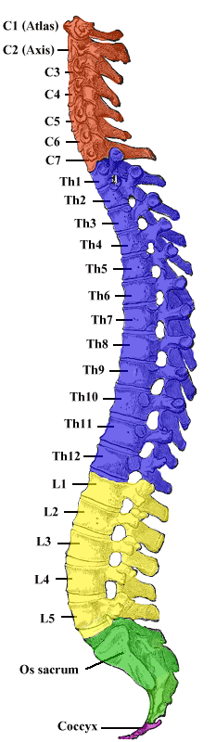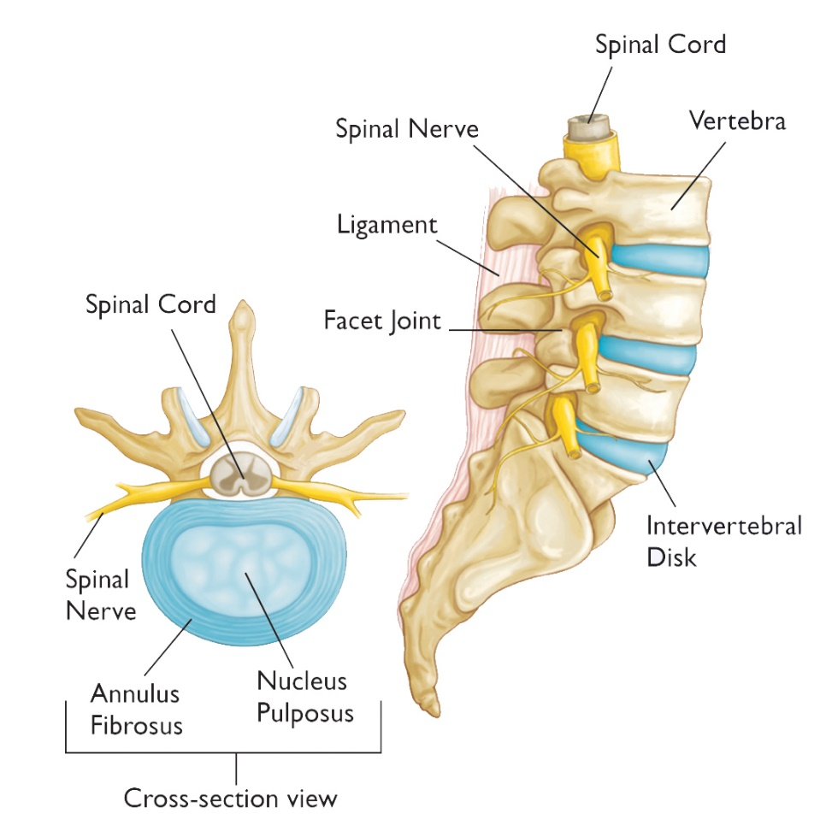

Figure 2 shows us the lower spine, the structure, and organisation of the vertebrae. As you can see between vertebrae, we have the intervertebral discs. These act as shock absorbers for the spine and allow a degree of movement. The back of the vertebrae come together to form the spinal canal which house the spinal cord. At regular intervals we have spinal nerves exiting the spinal canal laterally.
A cross section of the intervertebral disc can be seen in figure 2. The spinal discs are comprised of an outer fibrous ring, the annulus fribrosus, which houses an inner gel like substance, the nucleus pulposus.

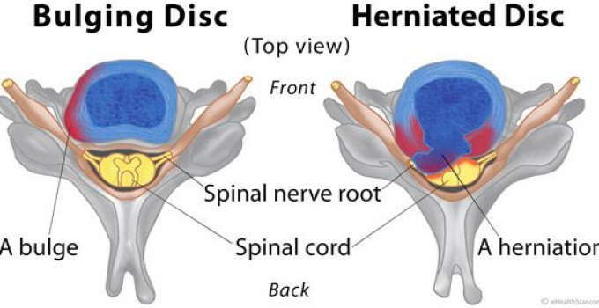

Slipped/bulging disc

Bulging discs also known as slipped discs are when the intervertebral disc is pushed backwards towards the spinal canal. This can be due to spinal trauma, excessive weight, a weak core, lifting heavy weights with bad form and sitting for hours on end, amongst other things. A lot of bulging discs will be asymptomatic with the patient experiencing no pain at all. Only when the protrusion presses against the spinal cord in the back or spinal nerves on the sides does it lead to localized pain in the back but also pain that travels down the lower limbs, from the buttocks to the feet.

Herniated disc

A disc herniation is very similar to a disc bulge both in its causes and symptoms. The difference is that in a disc herniation, the nucleus rips through the outer layer of the disc (annulus fibrosis) and is the substance that touches the spinal canal and the nerves. The failure of the disc to contain its own nucleus produces an inflammatory response with white blood cells attacking the “foreign” substance (the nucleus). This is painful but quite useful in “reabsorbing” the herniation. The white blood cells “eat” the protruding nucleus acting like miniature surgeons. Disc bulges do not create this immune response as the nucleus is never exposed. So counterintuitively, disc herniations have a greater chance of fixing themselves through reabsorption. Important to note: Pain killers stop the immune response. They should be avoided except to deal for the most extreme bursts of pain.

The path to recovery

Surgery

Surgery is either the first or last option in the recovery process.
It is the first option if:
- The trauma leading to the slipped disc/herniation requires immediate correcting
- The patient has lost control of bladder or bowel
- The patient has developed neurological sexual dysfunction
- The patient has developed muscle weakness
- And more
Unless one of these high priority symptoms is present, surgery should only be considered once all other conservative treatments have been tried and have failed to improve the patient’s condition. Even then, surgery does not guarantee a permanent result but does involve risk (including paralysis) so should truly be a choice of last resort.

Centralization versus Peripheralization

We need ways to gage progress. As professionals we will require feedback from our patient to determine whether an exercise or a stretch is potentially helpful or not. The following concepts come in quite handy in studying a client’s progress towards recovery.
“Centralization denotes the progressive regression of symptoms from the periphery towards the midline. It is considered a positive indication in the treatment of lumbar disc herniation and sciatica”. Instead of the pain extending all the way to the feet, it starts retreating up towards the glutes and even localizes at the exact location of the herniation. This is good, desired and a sign of improvement.
“Peripheralization describes the advancement or worsening of symptoms”. Basically, the opposite of centralization, this is when the symptoms start going downwards to the periphery (legs/feet). Any activity or exercise that lead to peripheralization should be ceased immediately and avoided.

The path of recovery can be viewed as a pyramid. The client will stay on one level until they feel confident, they can move onto the next level. The client will still need to maintain the habits of the current level as he moves up to not lose his foundations!

Pilates

Core work
Extension exercises
Walking with core engaged

Lifestyle changes

There isn’t a set amount of time to spend in each phase of recovery. This will largely depend on the individual and how they respond to the activities in said phase. A rough estimate would be between 1-4 weeks per phase.

Recovery phase 1: Lifestyle changes.

- Spinal rotations (twists) should be avoided completely!
- Spinal flexion should be avoided completely! Adjustments required when
  - Sitting (use a back support, take frequent breaks)
  - Picking something from the floor (bend a knee and maintain a neutral spine)
  - Brushing your teeth/ shaving (standing up tall always)
- Maintaining a neutral spine whenever possible
- It is best to push things than pull (we tend to flex our spines when pulling)
- Avoid lifting heavy things and if carrying things make sure the load is balanced on both sides
- Learn to brace your core and activate both your transverse abdominis as well as your erector spinae muscle group.

Recovery Phase 2: Walking while maintaining the core engaged

Pain is unfortunately going to be your client’s companion for a while. However, we must resist the avoidance of physical rehabilitation as this will further weaken the body and increase the scale of the injury. A vicious cycle indeed. With regards to pain, we want to make sure it becomes more centralized and does not travel down the legs. Staying in bed is not a recovery protocol!
Your client’s first venture into activity should be to take progressively longer engaged walks. By engaged, we mean walks during which both the deep abdominals and low back muscles are activated. A co-contraction of the transverse adbominis and the erector spinae.
- To engage the transverse abdominis think about creating a vacuum in the belly and trying to maintain that inward pull
- To engage the erector spinae group, think about extending the spine by moving the shoulders behind the hips and trying to connect with the muscles
Put 1 and 2 together and you will be co-contracting your core. You should strive to maintain a neutral spine as well.
This exercise initiates the process of strengthening the core to provide better support for the spine.

Recovery Phase 3: Extension exercises

Spinal extensions will usually provide relief from the symptoms and place the spine in a position in which the bulge/hernia has space to return in its original position and possibly be reabsorbed.
Note: Spinal extensions will be the relaxing/resting position for clients with a disc injury. Our common stretch, the child’s pose, is spinal flexion and should totally be avoided by this population.
Practice spinal extensions a couple minutes at a time, 2 to 4 times a day.
Start with the basic exercises and progress as your body allows. Do not force progress. If you are in too much pain for a next level exercise, that is a sign you are still really benefiting from the previous version of it.
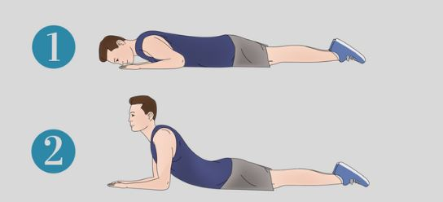
The figure above provides two versions of a back extension.
- The first is simply laying prone. This will provide a spinal extension unless the individual is overweight.
- The half-cobra pose is a first stage progression
There are many other progressions, but it is beyond our purpose to go through them all. You can do a back extension standing or do a cow stretch (without the angry cat part of the pose). We are looking for back extensions that we can amplify in a progressive manner.

Recovery Phase 4: Activating and strengthening the core

The core provides the “corset” that supports the body and the spine. Strengthening the related muscles will stabilize the spine and help with recovery.
Know your body, proceed gradually and remember we are avoiding all spinal flexion.
To activate the key muscles of the core, one or more of the following three exercise components must be present:
- Tightening of the abdominal muscles
- Involving the arms/legs
- Balancing
I am not trying to be comprehensive with the possible exercises here, but once again, the key thing is to start simple and progress as your body allows. If it is quite challenging, remain with your current exercise version.
Do each exercise for at least 10 secs, but up to one minute. These are holding exercises.
You will want to perform these between 2 to 4 times a day

The birddog
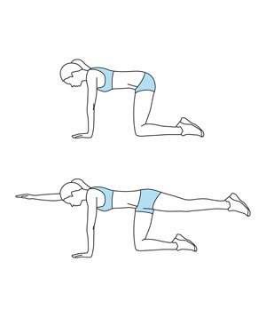

Half plank
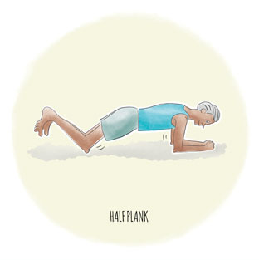

Side plank
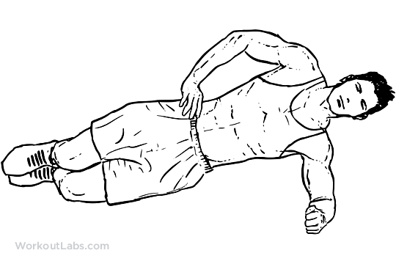
You will be able to find many progressions for these exercises. Start with the basics and increase the challenge in line with your body’s ability.

Recovery Phase 5: Structured exercise, Pilates most suitable

It is at this point of the recovery journey that we, as Pilates instructors, can become actively involved in the recovery process. It is hard to tell a person in pain that there is prior work required before you can help them but that is effectively the situation. Rushing through the recovery process will lead to frustration, more pain and potentially a worsening of the injury. Part of being a professional is to have the ability to say: “I am sorry, but we can’t help you until you have taken these steps and that will take some time”.

Spinal flexion avoidance
Spinal flexion should be avoided completely and if you think about it, you will realize that a significant portion of our repertoire involves spinal flexion. For example:
- Spinal articulation (roll up/down)
- Sit and stretch
- All curl ups
- Child’s pose
Spinal flexion occurs when the rib cage gets closer to the pelvis but also when the pelvis comes closer to the ribcage.
- Pelvic curls
- Shoulder stands (long/short spine)
Both types of spinal flexion should be avoided.

Spinal rotation avoidance

Spinal rotation can worsen disc injuries and should be avoid.
- Torso twists
- Woodchops
- Teasers

Back extensions and back exercises

We will work on strengthening the back muscles to improve posture whilst relieving the strain on the spine. We will also prioritize back extension exercises for their ability to decompress the spine, relieve pain and assist with reabsorption.
Back strengthening exercises:
- Low back flies
- Reverse flies
- Rows
Back extensions
- Prone box work
- Cow stretch
- Puppy pose
I recommend using the puppy pose as the default replacement for the child’s pose
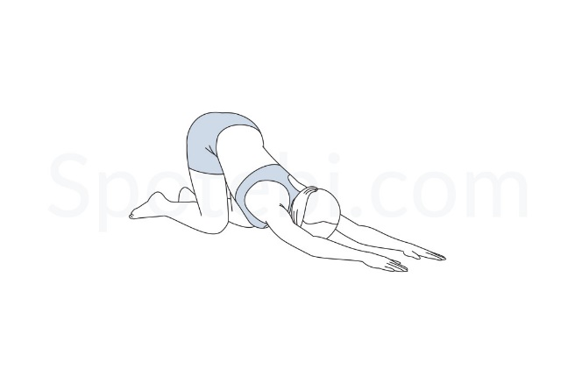
Practical: Time to ask your questions. Let’s spend some time analysing exercises that would or wouldn’t work as well as alternatives and progressions/regressions.

Additional considerations

Pain control and pain killers
Pain will need to be dealt with. Some protocols that may help include:
- Acupuncture
- Chiropractic manipulations
- Heat and ice
- Ergonomics (pain relieving positions such as puppy stretch…)
- Relaxation
- Epidural injections
- Aerobic exercise (endorphins)
Pain killers should be a temporary way to deal with pain. Their use can stop the healing process as well as hide peripheralization. Long term use can also cause damage to the stomach lining and can lead to death in extreme cases. Use rarely and only when needed.

Weight management

Holding excess weight puts a lot of pressure on the spine and encourages bad posture. Losing weight will usually be followed by a reduction in some symptoms.

Nutritional considerations

Building on the above, what one eats affects the body’s hormonal balance. Some foods are inflammatory and promotes inflammation while some do the opposite. A quick internet search will give you a list of such foods.

Final words

I hope this guide was instructive, clear, precise and actionable. A very important thing to remember is a spinal injury is a forever managed condition. The symptoms may rescind but one is never “healed”. This means we must stay vigilant, maintain the lifestyle changes and make Pilates a permanent part of our lives.

References:

“Herniated Disc”: A survival guide: Everything you need to manage your lumbar disc herniation without surgery by William Morgan published Feb 2014. I highly recommend you read this book. Easy, quick and clear read with great information.
“Wikipedia” for informative articles
Worthy of note: The NHS website provided what I considered inadequate information and was thus ignored. Not surprisingly the advice was to use pain killers and to rely on MRI scans to determine if surgery was required.

